**第26届全国信息存储技术学术会议（NCIS 2020）报告信息**

姓名：郭大維

单位：香港城市大學

个人简介：

Prof. Kuo received his B.S.E. and Ph.D. degrees in Computer Science from National Taiwan University and University of Texas at Austin in 1986 and 1994, respectively. He is now Lee Shau-Kee Chair Professor of Information Engineering, Advisor to President (Information Technology), and Dean of College of Engineering, City University of Hong Kong. He is also a distinguished professor of the Department of Computer Science and Information Engineering, National Taiwan University since August 2009. His research interest includes embedded systems, non-volatile-memory software designs, neuromorphic computing, and real-time systems.

Dr. Kuo is a fellow of ACM, IEEE, and US National Academy of Inventors. He is an executive committee member of IEEE TC on Real-Time Systems (TCRTS). Prof. Kuo received numerous awards and recognition, including the Outstanding Technical Achievement and Leadership Award from IEEE TCRTS and the Distinguished Leadership Award from IEEE TC on Cyber-Physical Systems in 2017. Prof. Kuo serves as the founding Editor-in-Chief of ACM Transactions on Cyber-Physical Systems (since 2015), an Associate Editor of ACM Transactions on Design Automation of Electronic Systems (TODAES) and IEEE Design & Test Magazine and a program committee member of many top conferences. He has over 300 technical papers published in international journals and conferences and received many best paper awards, including the Best Paper Award from ACM/IEEE CODES+ISSS 2019.

个人照片

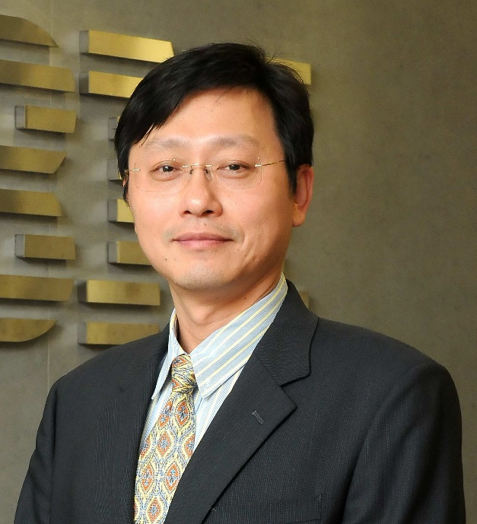

报告题目：Hardware, Software, and Application Co-Design to NVM Storage

报告简介：Software provides excellent and additional values to the designs of embedded systems, beside their hardware features. It closes the gap between user demands and hardware platforms. On the other hand, dilemma always exists on how to design software, such as modularity and optimization. In this talk, examples and solutions are presented for the co-designs of storage devices with respect to non-volatile memory characteristics.